Financial Modelling
Proceedings of the 23rd Meeting of the EURO Working Group
A.M.J. Skulimowski (Editor), Progress & Business Publishers, Kraków 1999, ISBN 83-912831-1-9

PRICE: PLN 160.00 80.00 (Poland), € 40.00 20.00 (all other countries), including shipping by surface mail
Air Mail Surcharge (first copy only): Europe and Mediterranean € 3.00,

USA and Canada $ 5.00, Rest of the World $ 7.00 SALES OFFER VALID BY DECEMBER 31, 2015!

ORDER FORM

Title: First Name:
Name:
Organization:
Department:
Address:
Postal Code: City: Country:
Telephone: Fax: E-mail:

Please send me ______ copy(ies) of “Financial Modelling-Proceedings of the 23rd Meeting of the EURO Working Group”, Ed.: A.M.J. Skulimowski, Progress & Business Publishers, Kraków 1999. ISBN 83-912831-1-9.
Include Air Mail Surcharge □ YES □ NO
Total order amount : € /PLN (delete the inappropriate currency): …………………………………….....………….……………..

METHOD OF PAYMENT

□ Please send me an invoice for pre-payment by direct bank transfer to the account:
Account Holder: | Fundacja Progress and Business, ul. Lea 12B, 30-048 Kraków, Poland
Bank: | PKO Bank Polski S.A.
Account No.: | PL91 1440 1127 0000 0000 0347 6634 (PLN)  PL10 1440 0000 0000 0375 0876 (EUR)
SWIFT: | BPKOPLPW
Transfer Specification: | Financial Modelling 23 Proceedings

Date: Signature:
□ Credit card payment
Please charge my credit card as follows (Credit card orders must be signed, scanned, and sent by e-mail to: sales@pbf.pl or sent by fax to +48 12 6368787)
Cardholder’s Name (exactly as on your credit card):
Card type: | □ | Visa | CVV2 / CVC2 / CVVII (the 3 or 4 digit code on the back of your Card):
 | □ | Master Card
Card No:
Card expiry date (month/year): |  |  | _____/___________
The bank which provides credit card: |  |  |  | Country:
Total payment amount in € / PLN:
Title of payment: |  |  | Financial Modelling 23 Proceedings
Cardholder’s address:
Please debit my credit card (Cardholder’s signature): |  |  | ………………………………… | Date: |  | …..……201..
Date of dispatch: up to 15 days upon the receipt of the payment.

Orders are to be sent to:
PROGRESS & BUSINESS FOUNDATION
Attn.: Ms. Alicja Madura, Scientific Publications Dept.
PL-30-048 Kraków, ul. Lea 12B, Poland
Phone: +48 12 636 0100, Fax: +48 12 636 8787
E-mail: sales@pbf.pl, URL: http://www.pbf.pl
By the same author:  Decision Support Systems Based on Reference Sets  AGH Publishers, Cracow 1996, softbound, 165pp, ISSN 0867-6631  PRICE: € 15.00 (50% OFF), including shipping by surface mail  Air Mail Surcharge: Europe and Mediterranean € 3.00  USA and Canada € 4.00, Rest of the World € 5.00 (first copy only)  ORDERS: use order form above, Transfer Specification: DSS 1996  □ Please send me ............ volume/s for the total amount of € ………  (limited number of copies in stock) | 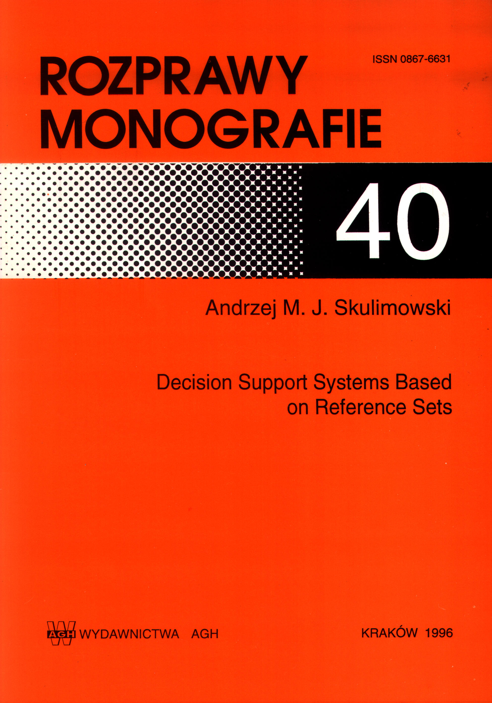
Looking into the Future of Creativity and Decision Support Systems  Proceedings of the 8th International Conference on Knowledge, Information  and Creativity Support Systems  Progress & Business Publishers, Cracow 2015, hardbound, 673pp, ISBN 978-83-939344-1-6  PRICE: € 60.00, including shipping by surface mail  Air Mail Surcharge: Europe and Mediterranean € 5.00  Rest of the World € 7.00 (first copy only)  ORDERS: use order form above, Transfer Specification: KICSS Proceedings  □ Please send me ............ volume/s for the total amount of € ……… | 